# **Eye Dissection**

# **For each lab dissection, make sure you are following these instructions. Failure to comply with these instructions will result in an unsuccessful completion of this lab. There is a rubric at the bottom of this report for specifics.**

# Click on File->Download->Microsoft Word to open the document and then save it to your computer with the following file name format “Your Name” “Name of Lab” (i.e. Ed Wolfe Brain Dissection). You will use this saved version to post your work.

# When you have completed the lab, upload this lab report in one of the following formats:

# PC Users: Submit as a Word or PDF document into Connect.

# Mac Users: Use the "export to PDF feature" under the File menu to save the lab report as a PDF and submit the PDF into Connect. If it is not submitted as a PDF, then I will not be able to open it and you will receive a grade of 0.

# This report cannot be emailed to the instructor for credit. All students are required to dissect their own specimen and submit their own report.

# Each image submission below is worth 5 points towards your overall grade. Any points not accounted for from the images will go towards your grade for completing the lab (e.g. if there are 10 images posted, then your grade will be 50 points from submitting correct images and 50 points for completing the lab).

# Make sure you are using a pointed object that came with the kit (not your finger) to identify the anatomy and that you are pointing to the exact piece of tissue. Do not put any wording or other graphics into these pictures, just point and take a picture.

# During the lab, you will be identifying anatomy and taking pictures of your work. All images should be resized to around 300 by 300 (a square) before uploading it to this document (see instructions below on how to do this).

# After you have uploaded it into Connect, the site will give it a grade of 0. This will be changed after the instructor grades the submission.

# Once graded the student can go into Connect and review the grade and any comments the instructor left.

# If you need additional help in identifying the location of the anatomy, refer to the APR program in Connect for clarification.

Follow the instructions in the Lab Manual you downloaded from Connect to complete your dissection (do not upload any images until you complete the dissection). When completed, the individual pieces should be scattered on your dissection tray. When you are ready, use your pointer to point to the following pieces of anatomy and take a picture. Save this picture to your computer, or the device you are using to work on this lab report, then follow these instructions:

1. The easiest way to transfer a picture from your phone to your computer is to email it to yourself.
2. For each image submission below, upload the picture below the name of the anatomy (e.g. insert the sclera picture under “1: Sclera”).
3. From the toolbar, click:
   1. Insert
   2. Pictures
   3. Double click on the image to insert it.
4. Here is an example of what your image should look like after it is submitted. If it is too large or too small, click on the image and then the corner or the image, to resize it to its appropriate dimensions mentioned above (around 300 by 300). Please keep the image as a square!

1: Image:



Notice the size of the image. Images should be presented in this size. Proceed to upload the following images, before moving on with the dissection.

1: Sclera:

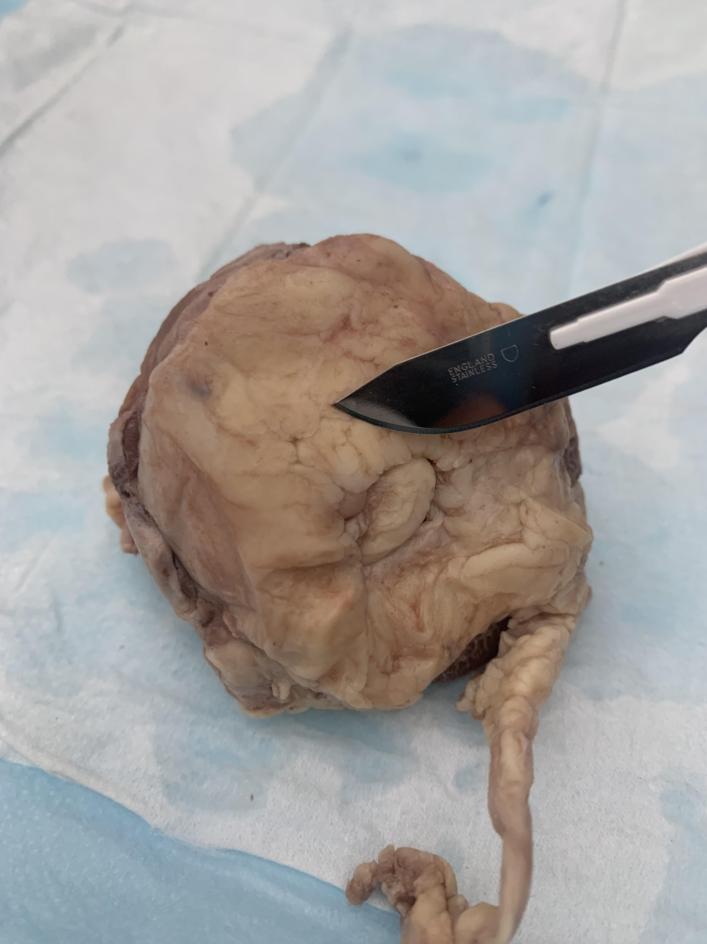

2: Cornea::

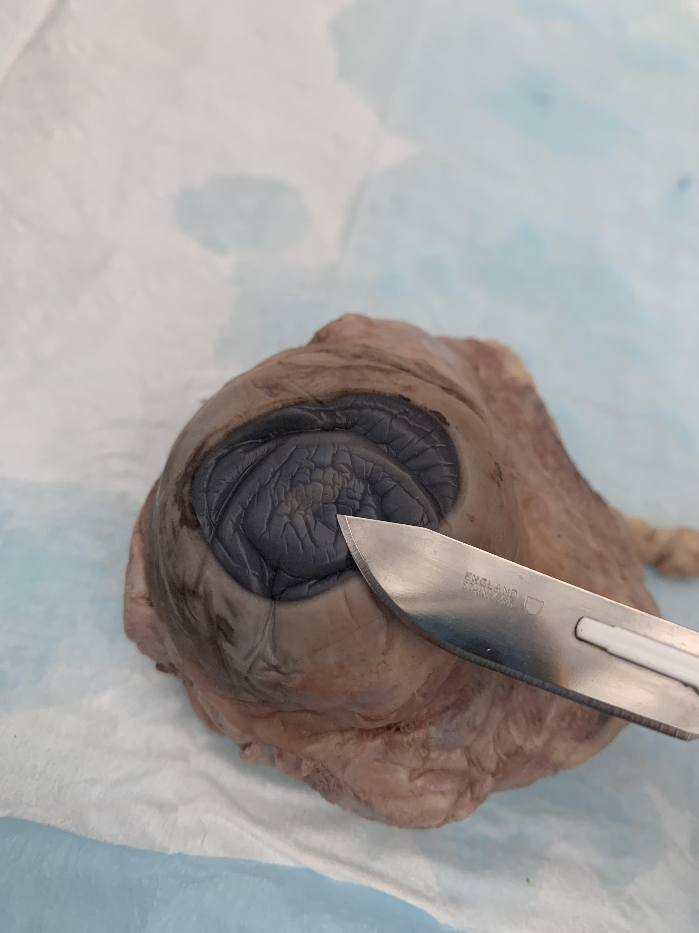

3: Choroid:

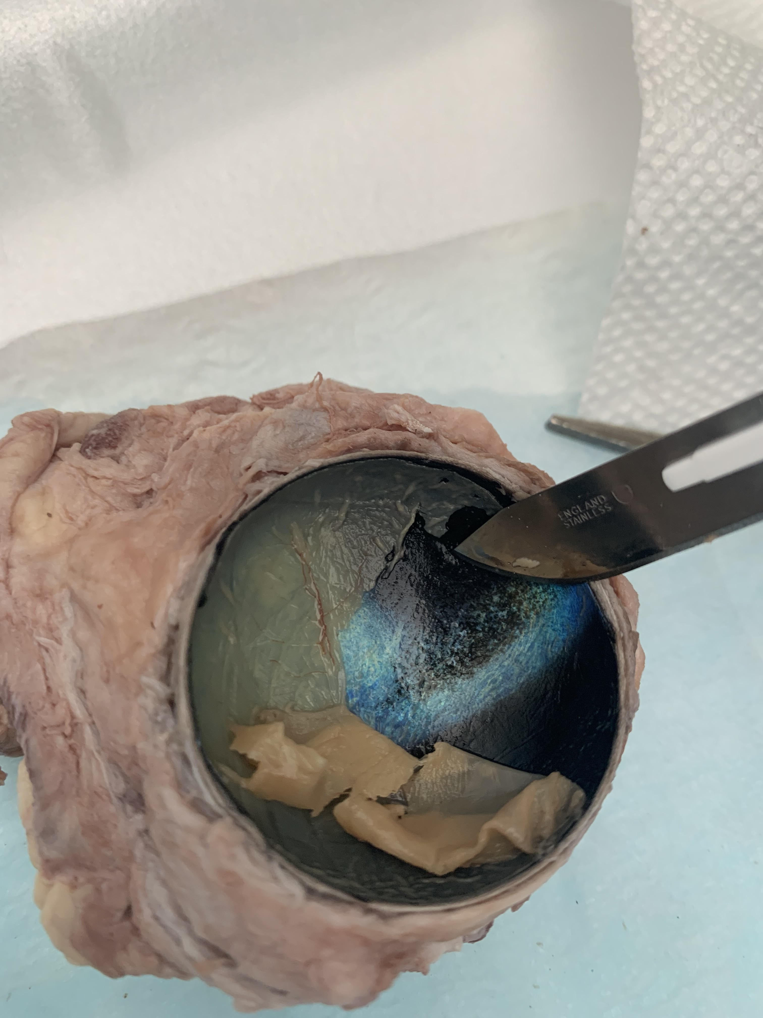

4: Iris:

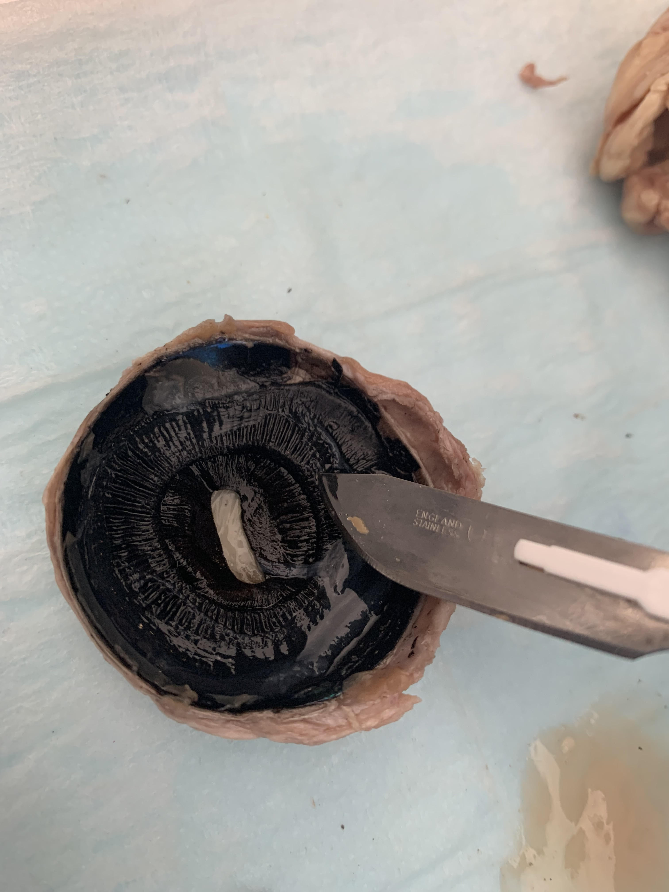

5: Pupil:

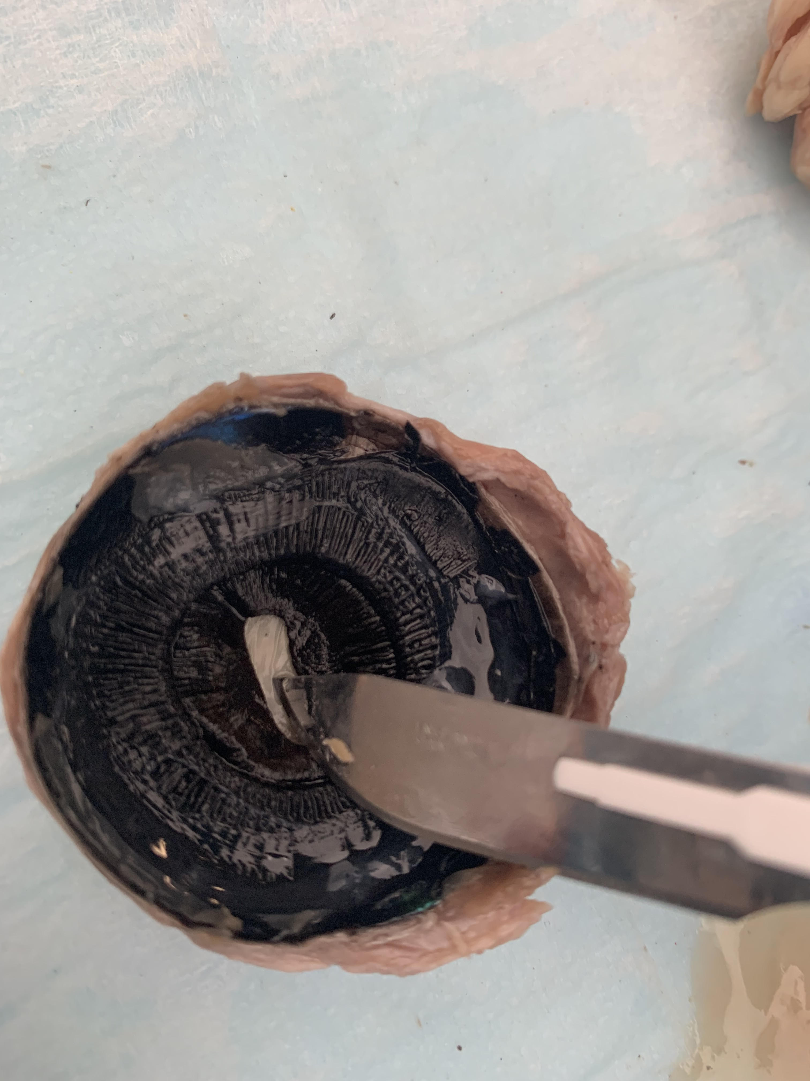

6: Lens:

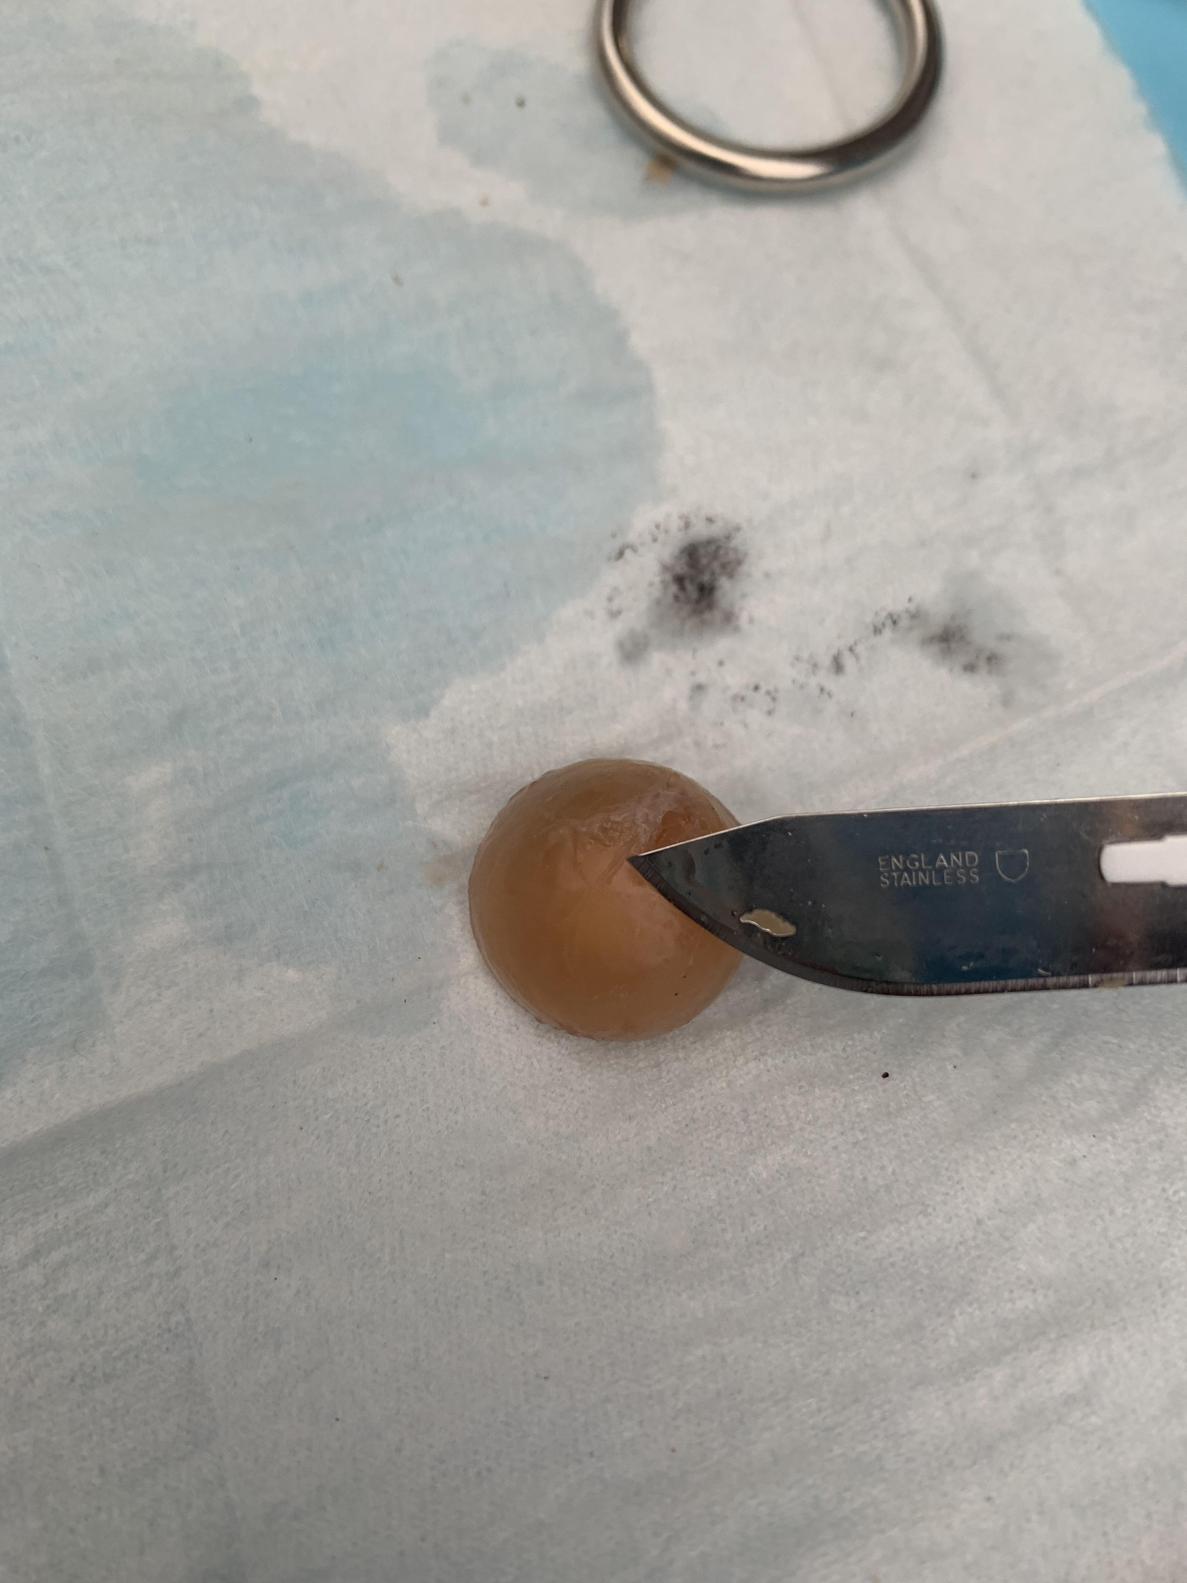

7: Retina:

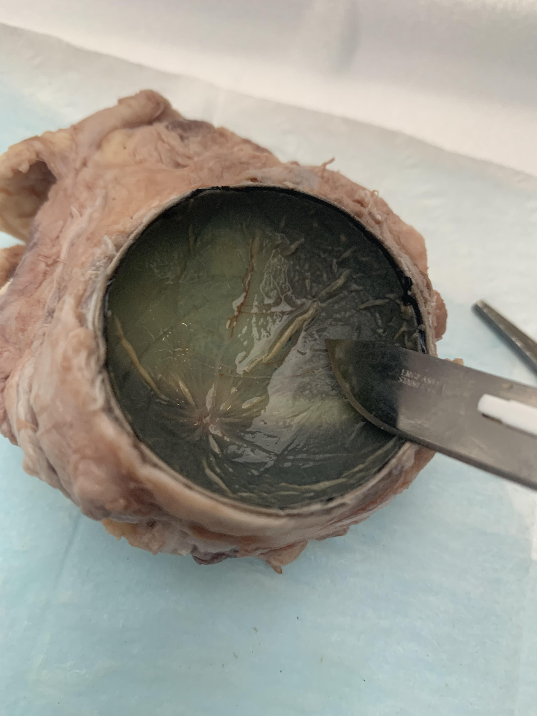

8: Optic Disc:

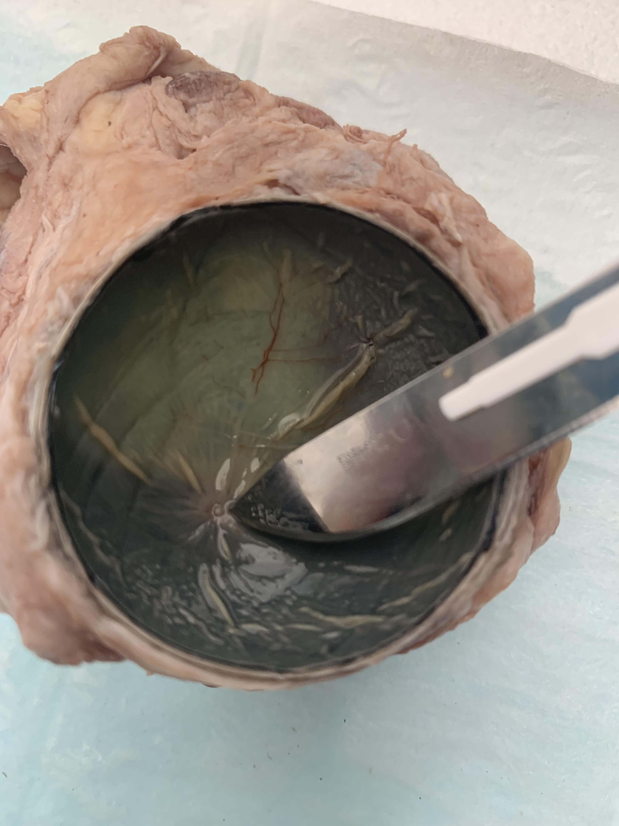

9: Optic Nerve:

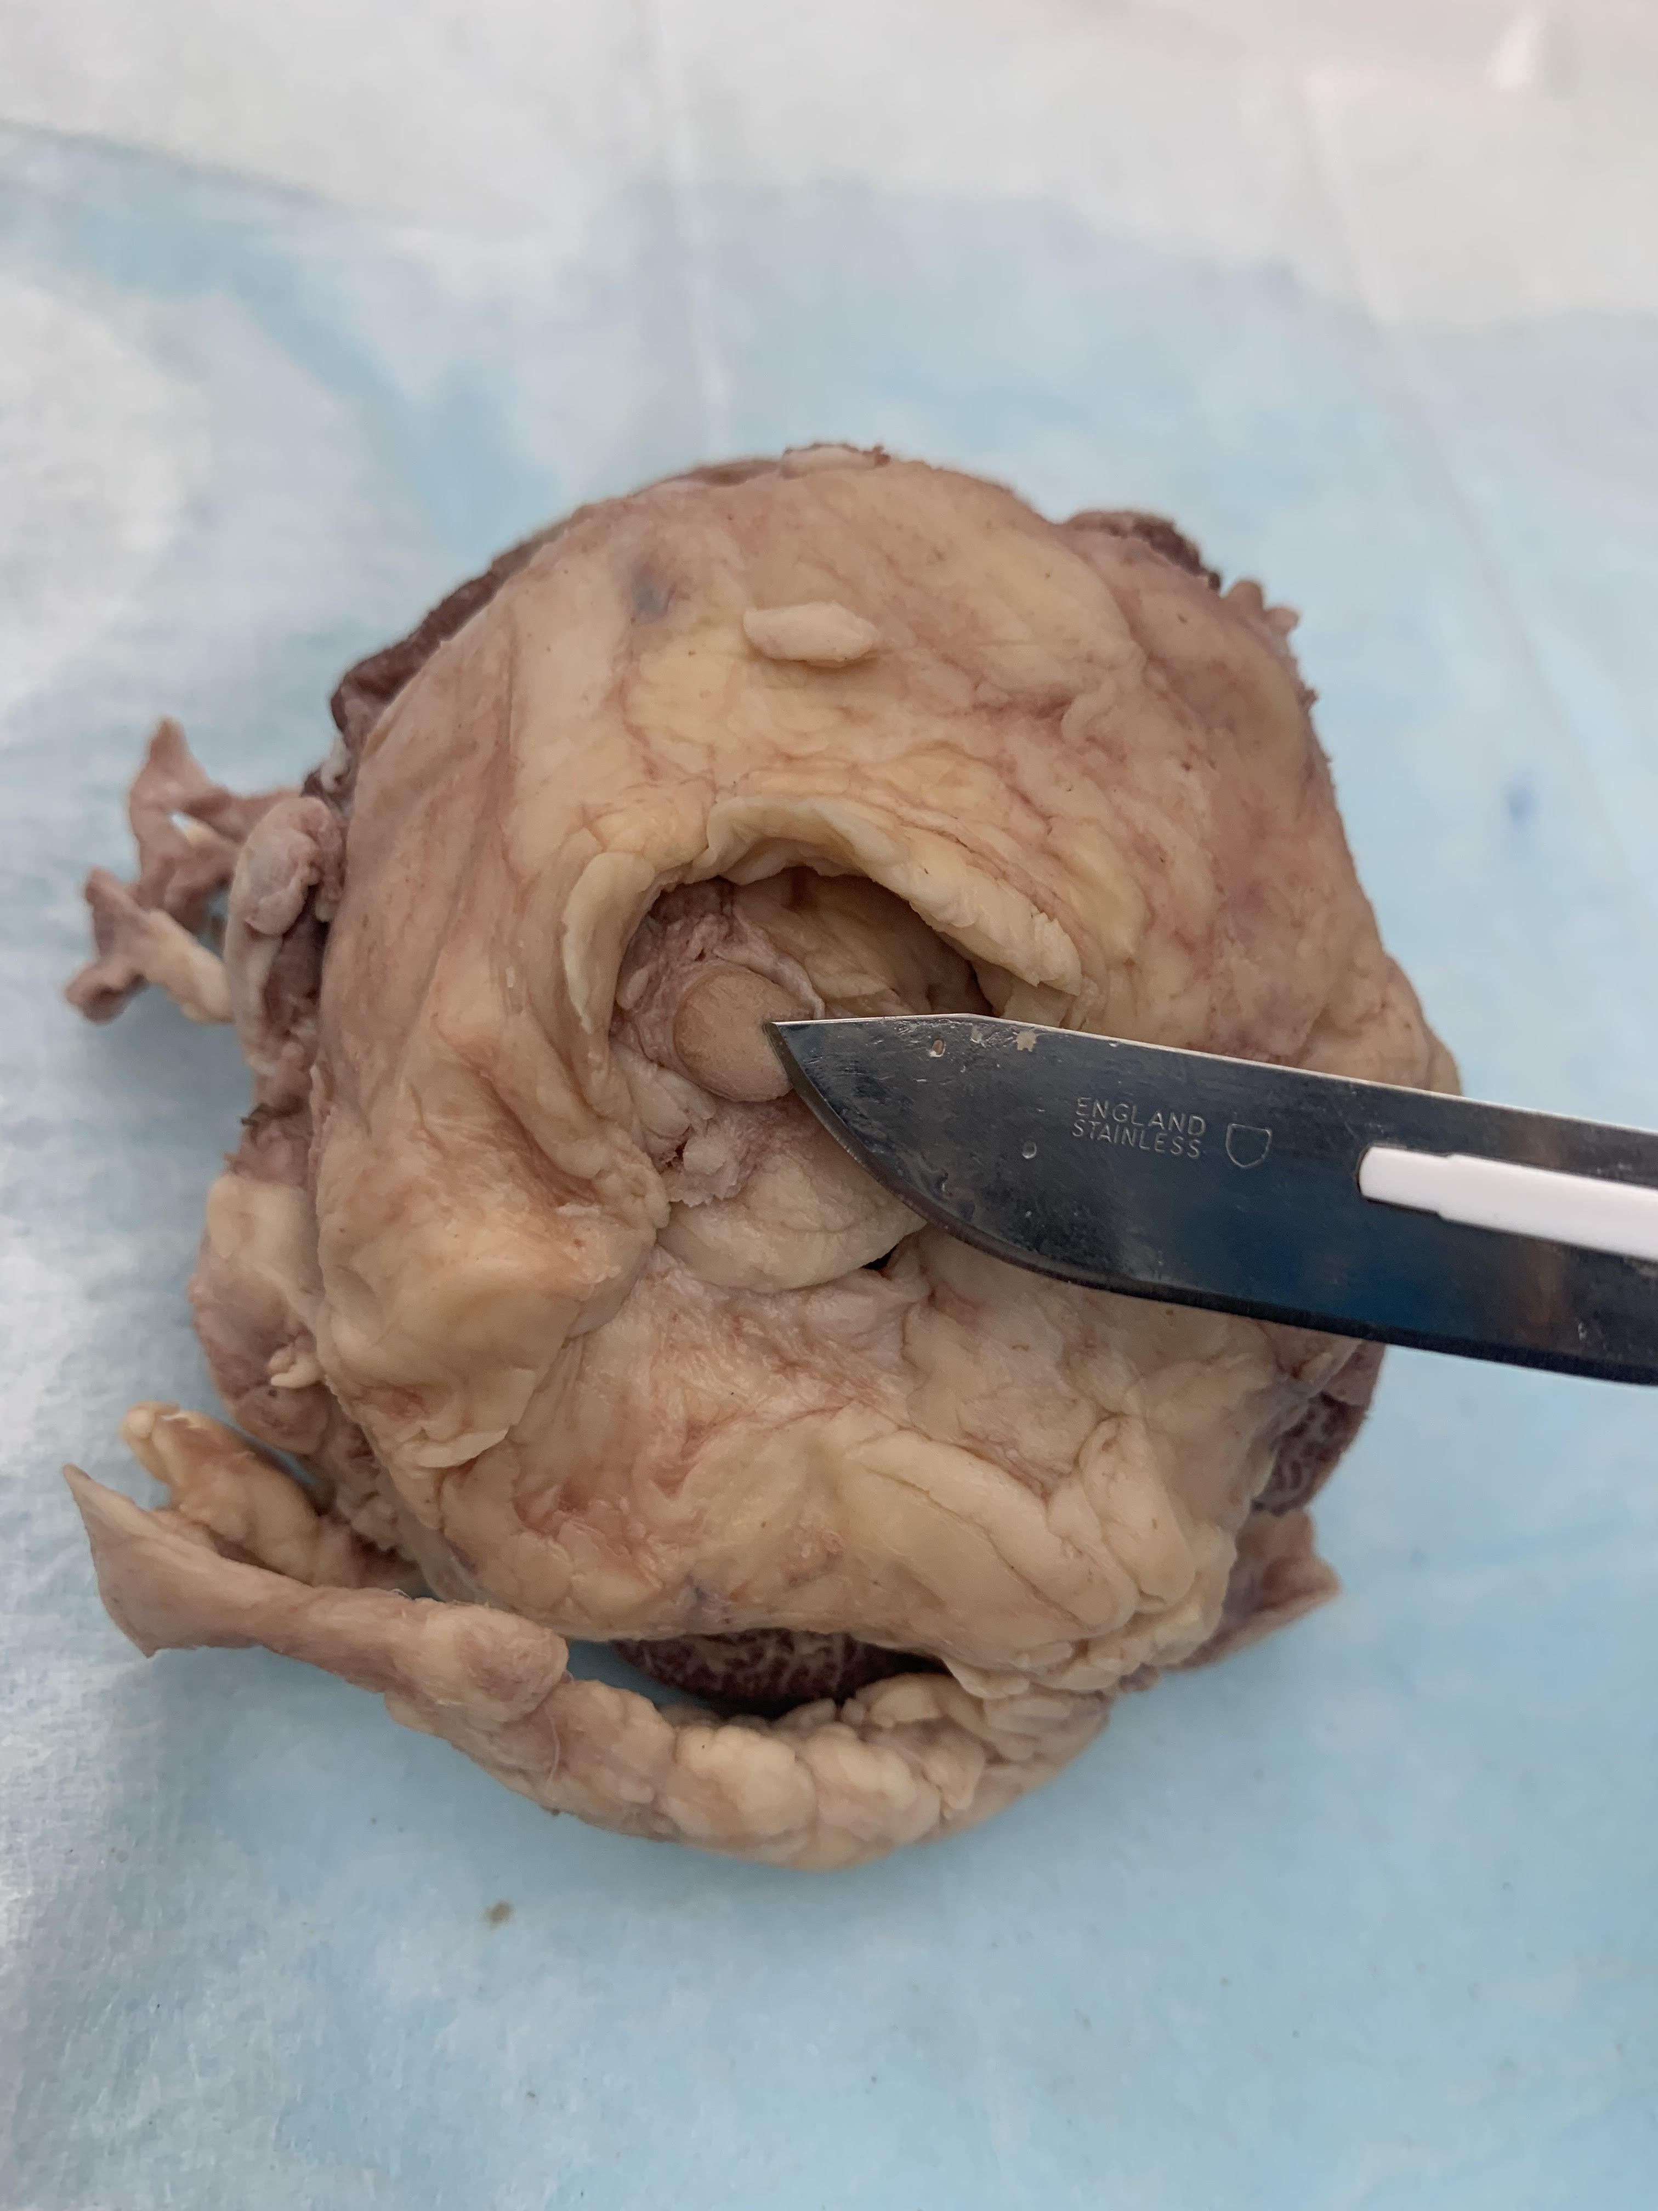

10: Vitreous Humor:

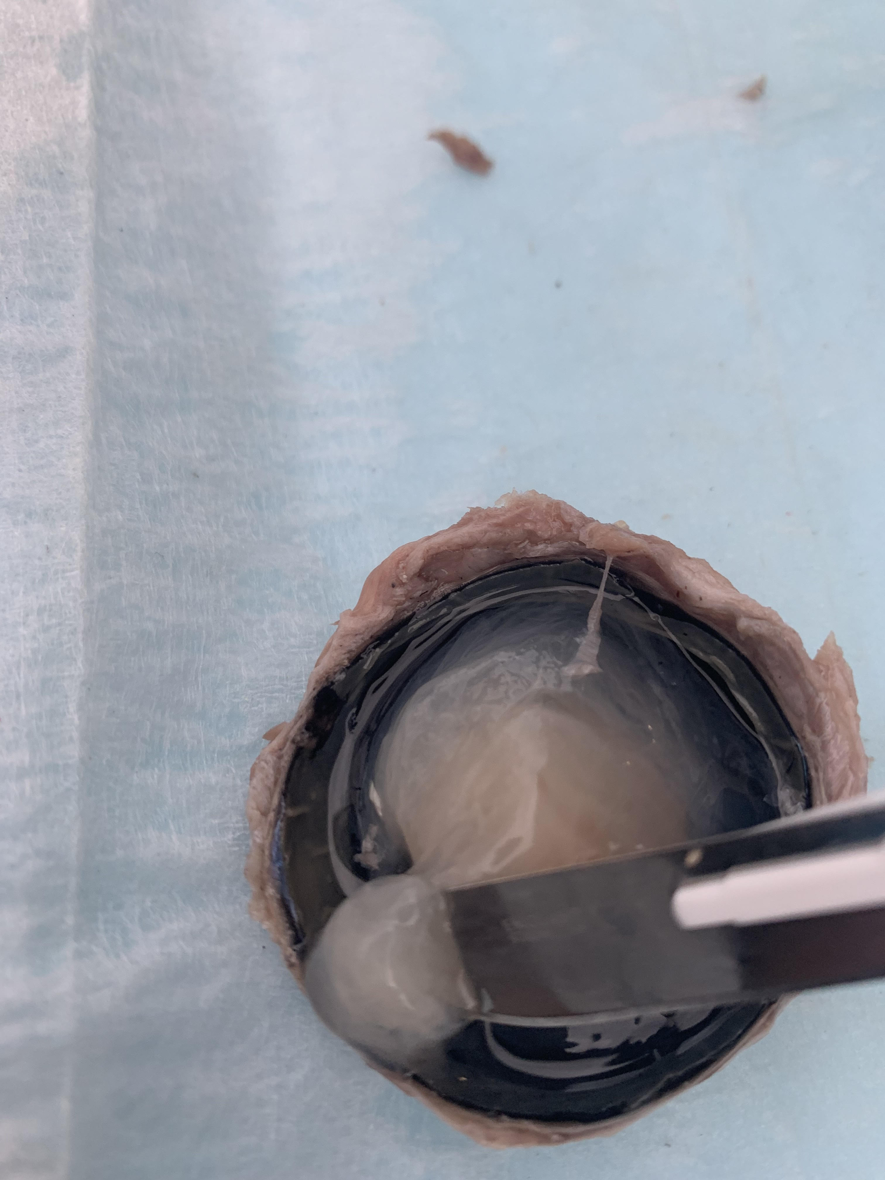

When you are done inserting images, save the document and submit it into Connect.

Rubric:

|  |  |  |
| --- | --- | --- |
| **Category** | **Yes** | **No** |
| **Of the 50 points for completing the dissection:** |  |  |
| 1: Was the document saved correctly with all information in the report (including instructions)? | No lost points | -10 points |
| 2: Was the item submitted as a word or pdf file? | No lost points | -10 points |
| 3: Did the student submit their own report? | No lost points | A grade of 0% and reported for cheating |
| 4: Did the student use a pointed object to properly identify anatomy? | No lost points | -20 points |
| 5: Were the images large enough to see (approximately 300 by 300) | No lost points | -20 points |
| 6: Were the images placed in the proper spot (under the heading for each image)? | No lost points | -20 points |
| **Of the 50 points for identifying anatomy:** |  |  |
| 7: Did the student properly identify the anatomy? | No lost points | -5 points/image |