MAT-172: Globalized Project
The city that I have always wanted to travel to is Bloomington Minnesota, because that is where the Mall of America is located, and I really hope I get to go there someday.
These are the average monthly temperatures for Saint Peter, Minnesota, which is near Bloomington and the Mall of America:
Jan | Feb | Mar | Apr | May | Jun | Jul | Aug | Sep | Oct | Nov | Dec
14.0 | 18.3 | 31.5 | 46.6 | 58.6 | 68.4 | 72.9 | 70.7 | 61.7 | 50.2 | 33.3 | 19.8

These are the daily averages for last month, August 2022:
71 | 78.5 | 73 | 69.5 | 75 | 72 | 68.5
66.5 | 67.5 | 72.5 | 69 | 68 | 67 | 65.5
65 | 69.5 | 69.5 | 70.5 | 66 | 66.5 | 67
68 | 71.5 | 73 | 68 | 66.5 | 74 | 75.5
70.5 | 66 | 72.5

Average for the month: ~ 69.8

Regression Graph & Stat Plot:
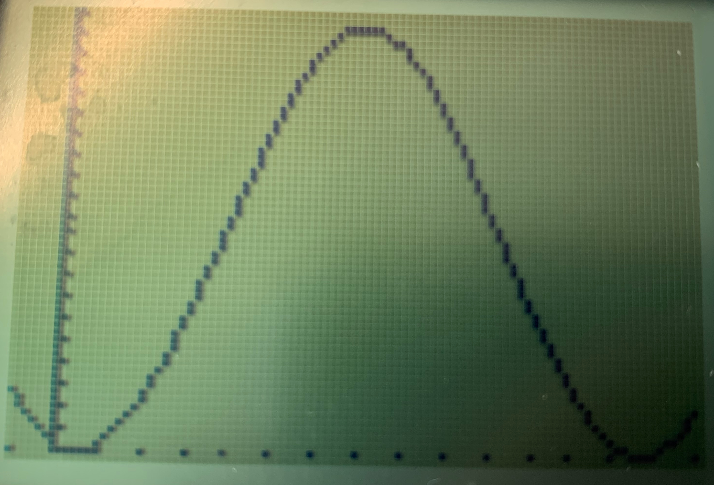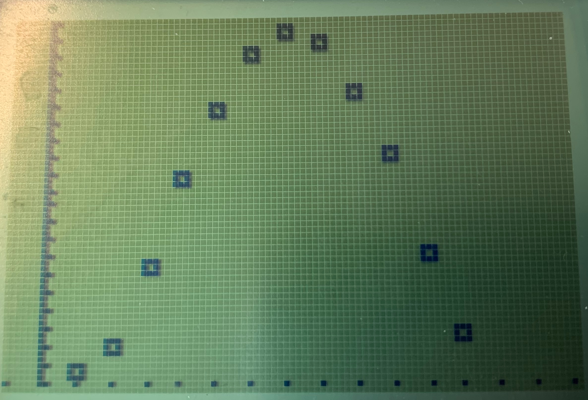
Equation: y= 30.63164965 * sin 0.4782416901 (x – 3.817127141) + 42.72206846
Amplitude: 30.63164965 Phase Shift: 3.817127141 Period: 4.18198589
Vertical Translation: 42.72206846 Range: [- 30.63164965, 30.63164965]

Average temperature for August according to graph: ~ 70.6
- The average found in the table above, 69.8, is like the number found in the graph, 70.6. The graph can be used to predict future forecasts, not to pinpoint exact forecasts. That is why the numbers are different.
- The worldwide climate site says that the monthly temperature average in August is 70.7, and the graph shows 70.6. This is because the data for the line graph was used from the monthly averages on the same website, so that is why the data is so similar.
Predicted Temperature for December 2022: ~ 21.4
- The average temperature in December according to the graph is 21.4, and the average temperature according to the world climate website is 19.8. This again shows how the graph is just used to predict what the temperature might be, and that the temperature will likely be within the range of the number produced by the graph.

Knowing the average temperature is especially important for future planning, and it is also helpful for tracking important changes in our environment, like global warming. Jobs like marine biology and even hurricane hunters can only work in certain temperatures and conditions that are ideal for their field of work. For example, it's best for marine biologists to work in clear conditions, at a moderate temperature (cold temperatures aren’t ideal for field work), and hurricane hunters need stormy conditions, especially strong stormy conditions.
During this project, I learned how to graph a regression on a calculator, and compare AI computed averages to actual averages, by using last month's temperatures compared to the world site that calculated the average based on many months’ worth of results. Although with the career I want to pursue, temperatures and conditions won’t affect my work, it is important to learn how to calculate averages in general and compare results from different sites or times.

